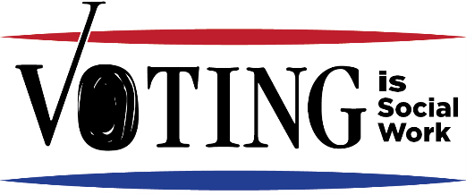
Know the rules in your state

Who is eligible to vote
To be eligible to register to vote you MUST
- Be a United States citizen
- Reside at the address you are registering; and
- Be 18 years of age.
Can 17-year-olds turning 18 by Election Day register in your state? Yes / No
Note: Be careful not to register non-citizens as this can hurt their application for citizenship

How to register to vote in your state

Send mail in form to: __________________________________________________________

Register In person at: __________________________________________________________

Is there online voter registration in your state? Yes / No Website? _____________________
- Does your state offer SAME DAY REGISTRATION? Yes / No
- Does your state offer EARLY VOTING? Yes / No
- Does your state have NO EXCUSE ABSENTEE VOTING? Yes / No
- Does your state have mail in voting? Yes / No
- Do you have to declare a party in order to vote in primary or caucus? Yes / No
In a closed primary, only voters registered with a given party can vote in that party’s primary. Special deadlines for changing party affiliation may apply.

Important Dates

The next primary date is _______________________________________

The next election day is ________________________________________

Polls are open: ________________________

Deadline for registering to vote is ___________ days before an election.

Absentee Ballots are available ______ days before an election.
Notes:

What are the voter id requirements to vote in my state? ______________________________
_____________________________________________________________________________________
Note: In all states, first time voters who haven't registered in person must present a valid photo ID and/or proof of residence, a copy of a current utility bill, bank statement, government check, paycheck, or other government document that shows the name and address of the voter.

Voting with a felony conviction

What are the rules for people with a felony conviction? ____________________________________
_____________________________________________________________________________________
Visit NonprofitVote.org to learn the voting laws for people with a felony in your state.

How to find out if someone is registered and where they vote
Check online at current address at Vote.org.

If you move, you must fill out another registration card if you move anywhere.

Voters with Disabilities
The Americans with Disabilities Act (ADA) is a federal civil rights law that provides protections to people with disabilities.
- If a voter has difficulty standing, they can ask to move to the front of the line or for chair.
- If a voter is visually impaired, there is an accommodation (usually via phone) at every polling place.
Notes:

How do residents of Nursing Homes, assisted living facilities, or psychiatric institutions Vote?
Contact your local Registrar of Voters. They are mandated to visit these types of living locations to provide supervised absentee voting.
Notes:

Victims of domestic violence, sexual assault, stalking or risk of injury to a minor
Victims of crimes can take part in the Address Confidentiality Program (ACP) called Safe at Home. For information, go online to http://nnedv.org/resources/coalitions.html to find your local Domestic violence center.
Notes:

Homeless individuals can register and vote!
The homeless have a right to vote!
- Homeless individuals can list their shelter’s address, a street corner or park and will vote in that district.
- They will need a form of identification.

Absentee Ballots
Absentee voting is conducted before Election Day. A ballot is available to be mailed to voters who qualify. Rules vary in each state, visit https://www.vote.org/absentee-voting-rules/
Permanent Absentee Ballot
- Permanent Absentee ballots are available for those with disabilities and are unable to appear at the polls in person.
- To apply for a permanent absentee ballot, the voter submits a standard absentee ballot application, accompanied by a note from the voter’s physician, stating that the voter is unable to appear in person at the polls.
Emergency applications for absentee ballot can be filled out within six days of an election.

College Students
College students can vote via absentee ballot from home or register to vote at campus/local address. See dates and deadlines for absentee ballots and registration for the state in which you will vote.
Notes:

