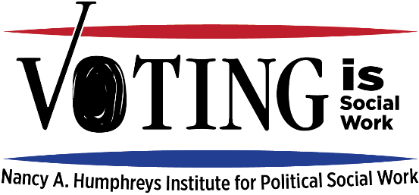

Integrating nonpartisan voter engagement into social services:
Step by step guide for organizations

All agencies with very few exceptions are allowed to register, educate and empower clients and staff to vote. Agencies may not engage in partisan politics by endorsing a candidate or party, giving money to a candidate or party. If you want more information about how to stay nonpartisan, go to votingissocialwork.org.

Note: If you are a student, you may choose to fill this out for your field agency or any other agency/organization with which you have personal or professional experience. We encourage you to meet with your field supervisor to discuss this assessment.

Name of organization/ school/agency:

Who are the targets of voter engagement efforts:
clients staff students parents community Board Other ______________

What online platform(s) would be easy and effective with our population: (VotER.org, TurboVote, Vote.org, SW Helper app (Rock the Vote), etc?)

Who are stakeholders in and out of the organization who should be involved in this effort, including local civic engagement organizations (e.g., League of Women Voters)?

What barriers do you anticipate at your agency?

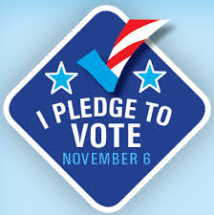
What resources would be helpful?

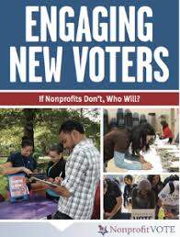

Voter Registration

When is the right time to ask whether someone is registered to vote at their current address? (check all that apply and add appropriate detail or open questions)
  - Check in/reception
  - Send text/email outreach
  - Telehealth setting
  - Staff meetings
  - Parent registering child
  - Other_______________________________________________
- Can we run/support voter registration drives at events or meetings?
When? _________________________________________________________________
- How can we share information about registration deadlines and resources in office, website and/or social media?
  - Email updates
  - Website
  - Text messages
  - Waiting Room?
  - Other____________________________________________________

Voter education: what information do people need to be informed voters?
Note: Individuals who register with the TurboVote will receive a text message or email with polling location links, absentee ballot application links and a reminder to vote on election day.
When/where/how to vote:
What should we send out to clients and staff:
- How to look up where to vote
- Who are their elected officials (federal, state and local)
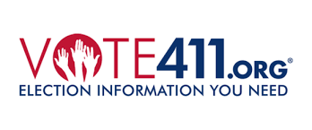
- Voter hotlines
- Rules for voting with a felony record
- Voter id requirements
- Rules for special populations (survivors of domestic violence, individuals experiencing homelessness, nursing home residents, etc.)
- How to fill out absentee ballots
- Other_______________________________________________________________
Information about elections, candidates and who represents them:
- Information on upcoming elections, including copy of the ballot
- Nonpartisan candidate events and guides
- Host a nonpartisan candidate forum or meeting at agency or school
- Links to find their elected officials.
- Other___________________________________________________________________
___________________________________________________________________________

GOTV: Encouragement to vote on Election Day! 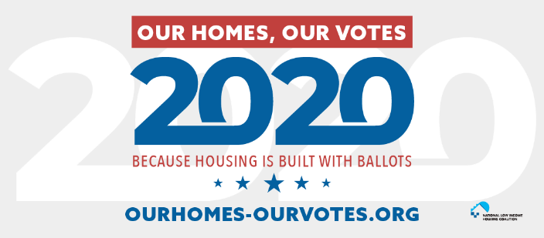
- Remind people why their vote matters in communications and public spaces
- Build excitement around an upcoming election?
- Run voter pledge drives (signing a “pledge to vote” increases likelihood of voting by 20+ %) Post answers on social media and/or display
- Other___________________________________________________________________
___________________________________________________________________________
What is the best way to communicate this voter information with our clients and staff?
- Group meetings
- Text message
- Social Media
- Email /newsletter
- Website
- Flyers
- Other_______________________
Make your plan as specific as possible!

2020 Census: helping your clients Be Counted!
The deadline for the 2020 Census is September 30, 2020 (which was moved up a month unexpectedly). Every person missed a decade of lower funding (estimated at $15-$30,000 per person missed), political power and investment. How can your agency encourage and support clients, staff and leaders to complete the census?

More ideas/best practices to integrate voter engagement into agency operations. Go to www.VotingisSocialWork.org for more information and resources
- Train staff and leaders for buy-in and support
- Designate lead “voter ambassador(s)” for agency
- Add question about voter registration to client in-take form.
- Have staff wear VotER badges with text and QR codes.
- Conduct voter registration drives at events.
- Add online voter registration link, resources and/or deadlines to organization website
- Post promotional materials and voter information in waiting room
- Discuss voter registration and voting in support groups
- Email staff and clients about upcoming voter registration deadlines
- Partner with League of Women voters on voter education materials to distribute to clients
- Help clients or staff apply for absentee ballot
- Share information about candidate forums and/or nonpartisan candidate guides via email and waiting room.
- Post voter bill of rights and share voter hotlines
- Promote upcoming elections and post sample ballots
- Help clients and staff look up who represents them
- Encourage clients/staff to contact elected officials
- Host a forum or invite elected officials to agency
- Run visible voter pledge drive leading up to election (e.g., WHY I VOTE)
- Sign up for webinars and resources at nonprofitvote.org

